7 – CREDIT CARD SYSTEM

USE CASE DIAGRAM:

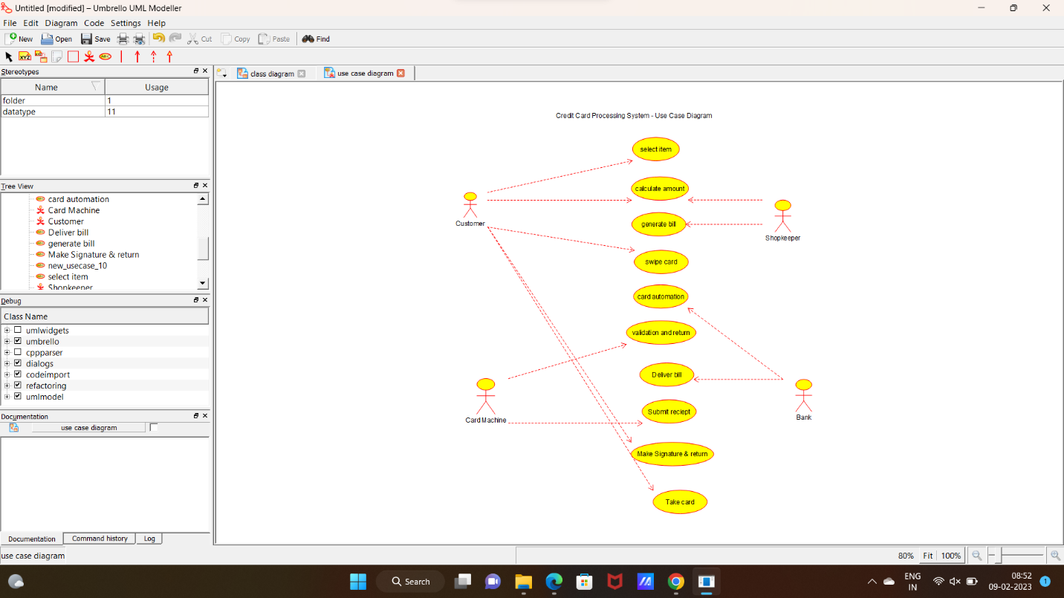

2:CLASS DIAGRAM:

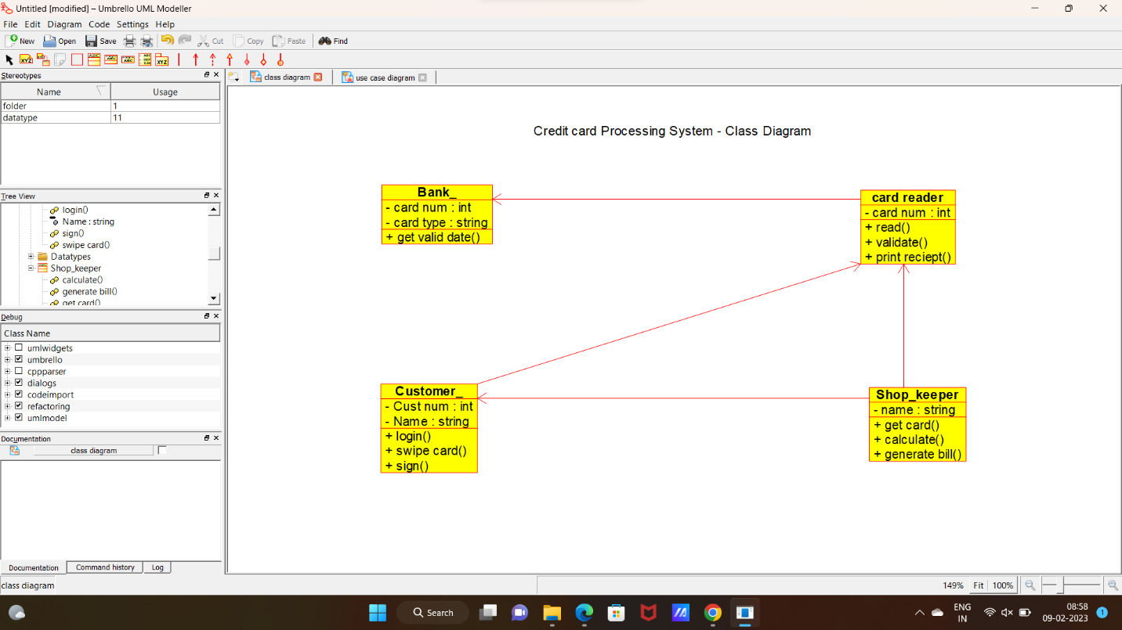

3:SEQUENCE DIAGRAM:

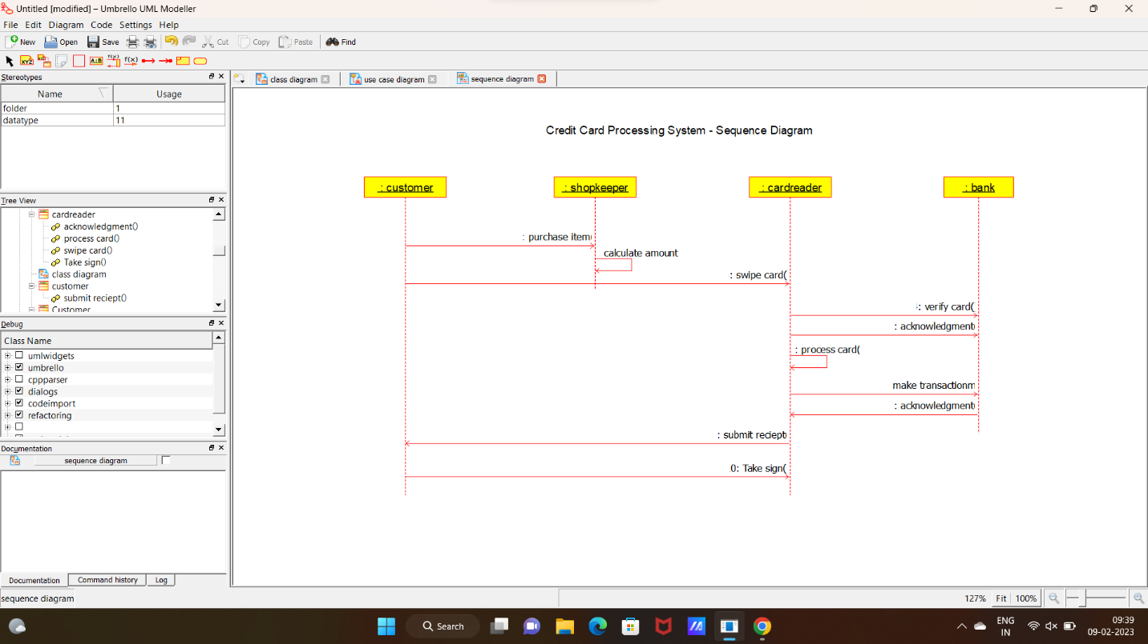

4:STATE CHART DIAGRAM:

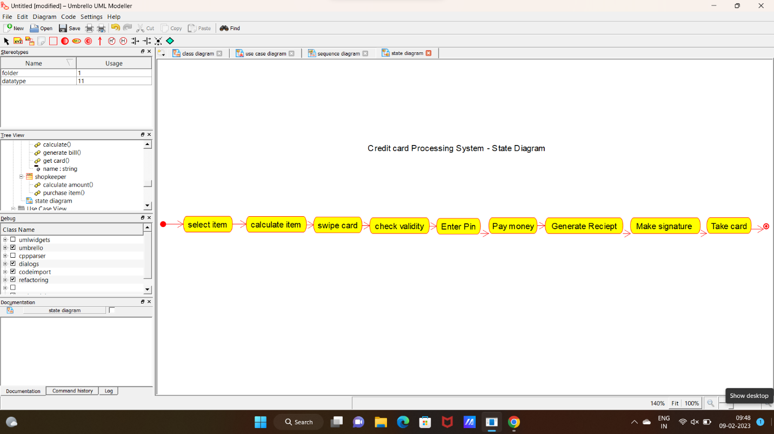

**CODE:**

BANK:

#include "Bank_.h"

// Constructors/Destructors

//

Bank_::Bank_ () {

initAttributes();

}

Bank_::~Bank_ () { }

//

// Methods

//

// Accessor methods

//

// Other methods

//

void Bank_::initAttributes () {

}

CARD READER:

#include "card_reader.h"

// Constructors/Destructors

//

card_reader::card_reader () {

initAttributes();

}

card_reader::~card_reader () { }

//

// Methods

//

// Accessor methods

//

// Other methods

//

void card_reader::initAttributes () {

}

CUSTOMER:

#include "Customer_.h"

// Constructors/Destructors

//

Customer_::Customer_ () {

initAttributes();

}

Customer_::~Customer_ () { }

//

// Methods

//

// Accessor methods

//

// Other methods

//

void Customer_::initAttributes () {

}

SHOP KEEPER:

#include "Shop_keeper.h"

// Constructors/Destructors

//

Shop_keeper::Shop_keeper () {

initAttributes();

}

Shop_keeper::~Shop_keeper () { }

//

// Methods

//

// Accessor methods

//

// Other methods

//

void Shop_keeper::initAttributes () {

}